Recommendation Systems

What is a Recommendation System?
A Recommendation System is a subclass of information filtering systems designed to suggest items to users based on their past behavior, preferences, or interactions.
They are widely used in:
- E-commerce (e.g., Amazon)
- Entertainment (e.g., Netflix, Spotify)
- Social media (e.g., Facebook, YouTube)
- News platforms (e.g., Google News)
Goals:
- Personalize user experience
- Improve engagement
- Increase sales/conversions
- Retain users
How Does a Recommendation System Work?
- Collecting User Data
  - Explicit: Ratings, feedback, reviews
  - Implicit: Clicks, views, purchases, browsing history
  - Once we collect explicit or implicit feedback, you can create a user-item rating matrix out of it
- Storing the Data
  - Stored in structured (SQL, NoSQL) or unstructured (logs, JSON) formats
  - Cloud platforms or local databases
- Analyzing the Data
  - Apply techniques like clustering, classification, regression
  - The goal is to understand user interests, segment users, and items
- Filtering and Recommending
  - Use algorithms (content-based, collaborative, or hybrid)
  - Generate top-N recommendations or personalized suggestions

Types of Recommendation Systems

1. Content-Based Filtering

What is Content-Based Filtering?
A Content-Based Recommendation System recommends items to users by analyzing the features of items and matching them to the preferences derived from user interactions.
Core Idea:
"If you liked items with certain attributes in the past, you'll probably like similar items in the future."

Example Use Case:
In Netflix or IMDb, if a user watches and enjoys Batman Begins and The Dark Knight, the system might recommend The Dark Knight Rises, as it shares:
- Same genre (Action/Thriller)
- Same actors/director
- Similar user reception

Utility Matrix
A utility matrix is used to represent user-item interactions:
- Rows: Users
- Columns: Items
- Values: Ratings (explicit) or Interactions (implicit)
Example:
User / Movie | Batman Begins | The Dark Knight | Mean Girls | ...
User A | 5 | 4.5 | ?
User B | ? | ? | 4.0
This matrix helps track what users like, though it's often sparse.

Item Profiles
An item profile is a vector representation of a content item’s features.
For movies, this might include:
- Genres (Action, Romance, Comedy, etc.)
- Cast and Crew
- Keywords from plot summary
- Year of release
These attributes are transformed into vectors using TF-IDF or other embedding techniques.

TF-IDF Vectorization
TF-IDF (Term Frequency-Inverse Document Frequency) is commonly used to convert textual item data (like plot summaries or descriptions) into numerical vectors.

TF (Term Frequency)
- Measures how frequently a term appears in a document.
- Normalized by the frequency of the most common word.

IDF (Inverse Document Frequency)
- Measures how unique a term is across all documents.
- Rare terms get higher weight, common terms get lower weight.
By multiplying TF and IDF, you get the TF-IDF score, which tells you how important each word is in that document.
Outcome: Converts each document (or item) into a sparse high-dimensional vector.

User Profiles
A user profile is generated by aggregating the item profiles of the items the user has interacted with.
- Often computed by taking the mean or weighted sum of the item vectors the user liked/rated.
- Represents the user’s preference vector.

2. Collaborative Filtering

Core Idea:
Collaborative Filtering (CF) makes recommendations by identifying patterns across users and items without requiring domain-specific knowledge about the content. It relies on the assumption:
“Users who agreed in the past will agree in the future about other items.”

Memory-Based vs. Model-Based Collaborative Filtering

1. Memory-Based Collaborative Filtering

Description
- Directly uses the user-item interaction matrix.
- Computes similarities between users or items using distance metrics.
- Makes recommendations based on these similarity scores.

Types:
- User-User CF: Find users similar to the target user and recommend items they liked.
- Item-Item CF: Recommend items similar to those the user already liked.

Advantages:
- Easy to implement
- Intuitive and explainable
- No training time

Limitations:
- Scales poorly with large user-item matrices
- Suffers from data sparsity
- Struggles with cold start (new users/items)
- Often used with implicit feedback

2. Model-Based Collaborative Filtering

Description:
- Uses machine learning models to predict missing entries in the rating matrix.
- Learns latent features of users and items from interaction data.
- Can incorporate both explicit (ratings) and implicit (clicks, views) feedback.

Common Techniques:
Method | Description
Matrix Factorization | Decomposes rating matrix into user and item latent factor matrices (e.g., SVD).
SVD (Singular Value Decomposition) | Popular for reducing dimensionality and learning latent factors.
ALS (Alternating Least Squares) | Optimizes latent matrices for sparse datasets (used in Spark MLlib).
Deep Learning | Neural Collaborative Filtering (NCF), Autoencoders.
Clustering | Groups users or items based on interaction similarity.

Advantages:
- More scalable and accurate for large datasets
- Can handle sparse matrices better
- Learns complex and latent relationships
- Supports real-time prediction

Limitations:
- Requires model training
- More complex to implement

Types of Memory-Based Collaborative Filtering:

User-User Collaborative Filtering (UUCF)
- Finds similar users to the target user based on their interaction history.
- Recommends items that similar users liked but the target user hasn’t seen.
Steps:
- Compute similarity between users (e.g., cosine similarity, Pearson correlation).
- Select top-K similar users.
- Aggregate their item preferences.
- Recommend the top items.

Item-Item Collaborative Filtering (IICF)
- Instead of comparing users, this compares items based on user ratings.
- For each item a user has rated, recommend similar items.
Steps:
- Construct an item-item similarity matrix.
- For a user’s rated items, find the top similar items.
- Recommend items with highest aggregated similarity scores.
Used by: Amazon (since it scales better and is more stable over time than user-user).

Recommendation Methods

1. Cosine Similarity
- What it does: Measures the cosine of the angle between two vectors (user profile and item profile).
- Purpose: Quantifies how similar a user’s preferences are to an item’s features.
- Use Case: Recommending items (e.g., movies, products) that closely match a user's preference profile, often used in content-based filtering.

2. Classification Models
- What it does: Uses supervised machine learning (like Decision Trees, SVM, Logistic Regression) to predict user-item relevance.
- Inputs: Combine user features (age, gender, history) and item features (genre, brand, price).
- Output: Binary (like/dislike) or continuous (rating) prediction.
- Use Case: Recommend whether a specific item should be shown to a user; commonly used in e-commerce and ad targeting.

3. Matrix Factorization
- What it does: Decomposes the sparse user-item matrix into two low-dimensional matrices of latent features.
- Goal: Learn hidden factors (e.g., genre preferences, user behavior) that influence ratings.
- Use Case: Netflix, Spotify, and other large-scale recommenders where data sparsity is a problem.

4. K-Nearest Neighbors (KNN)
- What it does: Finds the top-K most similar users or items using distance or similarity metrics (e.g., cosine similarity).
- Types:
  - User-User KNN: Recommend based on similar users.
  - Item-Item KNN: Recommend based on similar items.
- Use Case: Amazon's “Customers who bought this also bought…” uses Item-KNN.

Challenges in Collaborative Filtering:
Issue | Description | Solutions
Cold Start | Can’t recommend items for new users or items without history. | Use hybrid models, ask users to rate a few items, or use content-based methods.
Data Sparsity | User-item matrices are usually very sparse (most users interact with only a few items). | Apply matrix factorization (like SVD), clustering, or dimensionality reduction.
Scalability | As the number of users and items increases, computational cost grows. | Use approximate nearest neighbor (ANN) search or sampling techniques.

Benefits of Collaborative Filtering:
- No need for detailed item metadata (works even if items are untagged).
- Captures subtle and complex user preferences.

3. Hybrid Recommendation Systems

What is a Hybrid System?
Combines content-based and collaborative filtering. Uses both user/item features and interaction data. A hybrid recommendation system combines multiple filtering techniques to improve the quality, robustness, and flexibility of recommendations.
Why Hybrid?
To overcome the limitations of standalone methods like:
- Cold start (handled using content features)
- Limited personalization (resolved by combining preferences)
- Poor diversity (solved using multi-objective strategies)

Real-World Example: Netflix Hybrid System
Netflix blends:
- Collaborative filtering to detect similar users and preferences.
- Content-based filtering to recommend shows with similar tags, genres, actors.
- Contextual information like time of day, device type, watch duration.
- Ranking models to score and order final recommendations.
Netflix’s system has evolved using neural collaborative filtering, sequence models, and reinforcement learning to personalize the homepage.

4. Context Filtering in Recommendation Systems

What is Context Filtering?
Context Filtering refers to recommendation methods that take into account additional contextual information — such as time, location, device type, or session behavior — to provide more personalized and timely recommendations.
Instead of relying solely on user-item interactions, context filtering captures “when,” “where,” and “how” users interact with content.

Types of Context-Aware Recommenders
- Session-Based Recommendation
  - Focuses on interactions within a single session (e.g., a single visit to a website).
  - Assumes no long-term user history is available (good for anonymous users).
  - Example: Suggesting the next item in an online store cart session.
- Sequence-Based Recommendation
  - Analyzes the order and timing of past interactions over a longer period.
  - Builds on temporal patterns (e.g., what a user watches every weekend).
  - Example: Suggesting the next TV episode or genre after a binge-watching streak.

Techniques Used
Method | Description
K-Nearest Neighbors (KNN) | Simple memory-based filtering using session similarity
Markov Chains | Models transitions between items based on previous actions
Recurrent Neural Networks (RNNs) | Deep learning models that capture sequence patterns in data
Attention Mechanisms | Highlight important past interactions for predicting future ones

Recommendation Systems – Traditional Machine Learning Approaches

1. Matrix Factorization (MF)
Core Idea:
Decomposes the user-item interaction matrix into two lower-dimensional latent matrices capturing user preferences and item characteristics.

A. Implicit Feedback (e.g., views, watch time)
- Algorithm Used: Modified SVD with confidence weighting.
- Terminology:
  - 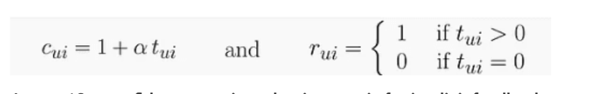
tui​: Interaction strength (e.g., how many times a user watched a movie)
cui=1 + α tui: Confidence matrix
The rating matrix rui is defined as rui = 1 if tui > 0 (indicating the user has watched the movie) and rui = 0 if tui = 0 (indicating the user has not watched the movie).
- Loss Function:
Weighted squared error with regularization:
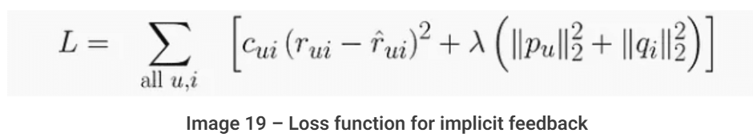
- Regularization terms for user and item feature vectors (pu and qi) are added to prevent overfitting and scaled by a parameter λ

B. Explicit Feedback (e.g., star ratings)
- Algorithm Used: Probabilistic Matrix Factorization, learns latent vectors for users (p)and items(q) by minimizing a regularized mean squared error (MSE) loss over known ratings
- Loss: Regularized Mean Squared Error (MSE)
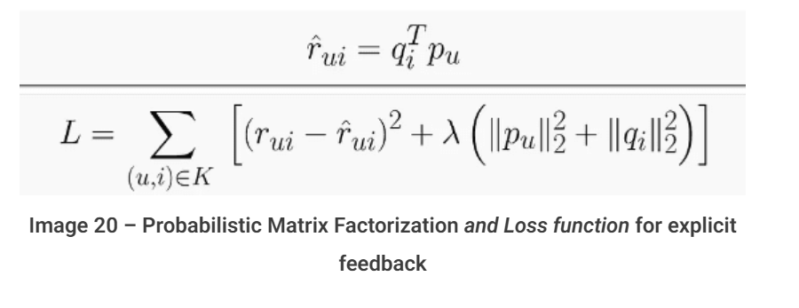
- Optimization:
  - SGD (Stochastic Gradient Descent)
  - ALS (Alternating Least Squares):
While SGD is easy to implement, it may struggle with non-convex loss functions. ALS, however, can transform the problem into a series of convex linear regression problems, which are easier to solve and can be significantly parallelized for speed

C. Hybrid Feedback – SVD++
- Combines implicit + explicit interactions.
- Enhancement: Incorporates the latent influence of all interacted items (even unrated).
- Improved Accuracy: More robust when users interact often but rate rarely.
2. Logistic Regression
Core Idea:
A linear classification model that predicts the probability of a user performing an action (e.g., clicking, buying).

Features Used:
- User demographics (age, location)
- Item features (price, genre)
- Context (time, device)
- Past behavior (clicks, likes)

Extensions:
Traditional logistic regression assigns a weight to each feature but does not consider how features interact with each other. Additional techniques are used to capture these interactions.
- Poly2 model: learns weights for each feature pair
- Tree-based transforms: use decision trees to generate derived features

3. Factorization Machines (FMs)
- What they are:
FMs are generalized low-rank models designed to approximate data in tabular format by modeling interactions between features using latent vectors.
- Key advantage:
Unlike traditional matrix factorization (which mainly models user-item interactions), FMs can handle complex interactions between any pair of features, not just user and item.
- How it works:
Each feature is represented by a k-dimensional latent vector. The interaction weight between two features is computed as the inner product of their latent vectors.
- Use case:
Useful in recommendation systems where feature interactions matter beyond just user-item pairs (e.g., user demographics × item category).

4 . Field-aware Factorization Machines (FFMs)
- Extension of FMs:
FFMs group features into fields (e.g., user info, item info, context).
- How it differs:
Each feature has multiple latent vectors, one for each field it can interact with. When calculating interaction weights, the latent vector used for a feature depends on the field of the other feature in the pair.
- Benefit:
Captures more nuanced and context-aware feature interactions than basic FMs

Deep Learning Approaches in Recommendation Systems

Overview
- DL models have greatly advanced recommender systems by leveraging large data and complex architectures.
- Unlike traditional ML, DL improves continuously with more data, enhancing accuracy and flexibility.

Life Cycle of DL-based Recommendation Systems
1. Training Phase
- Model learns to predict user-item interaction probabilities using historical data.
- Uses backpropagation and gradient descent to minimize prediction errors.
- Goal: Capture patterns in user behavior and item characteristics.
2. Inference Phase
- Trained model predicts interactions for new users/items.
- Steps:
  - Candidate Generation (find potential items for user)
  - Candidate Ranking (score/rank candidates by predicted preference)
  - Filtering (remove irrelevant candidates)
- Requires efficient real-time prediction for timely recommendations.

Workflow
- Collect user-item interaction data (e.g., ratings).
- Learn embeddings representing users and items (dense vectors encoding preferences/features).
- Train model to predict interactions from embeddings.
- For new recommendations, generate user context features and feed them to the trained model to produce personalized suggestions.

Key Components
- Embeddings: Convert categorical data (user/item IDs) into dense vectors capturing similarity in latent space.
- Core Architectures:
  - Feedforward neural networks (FNN) and Multilayer Perceptrons (MLPs) for non-linear interaction modeling.
  - CNNs for image-based features.
  - RNNs for sequential data like interaction histories.
- Additional features: User demographics, time info, item metadata can be included for better generalization.

Popular DL Models
- Neural Collaborative Filtering (NCF):
Combines matrix factorization with MLPs to learn complex user-item interactions non-linearly. Embeddings are multiplied and fed through MLP layers for final prediction.
- Variational Autoencoders (VAEs):
Encode user interactions into latent distributions, then decode to predict missing interactions, effectively handling sparse data.
- Wide and Deep (Google):
Combines a linear model (wide) for memorizing frequent patterns and a deep neural network for generalization with embeddings.
- Deep Learning Recommender Model (DLRM) by Meta:
Combines categorical and numerical features with embedding layers and MLPs. Explicitly models second-order feature interactions using dot products of embeddings, followed by an MLP for prediction.

Session-Based Recommendation Systems
- Goal: Predict user’s next actions within a single session, using sequential interaction data (e.g., clicks, views).
- Data: Sequences of user events during a session (viewing multiple products, videos, etc.).
- Models Used:
  - RNN variants: GRU, LSTM — capture temporal dependencies in event sequences.
  - Transformer-based models: BERT — use attention to focus on relevant past interactions.
- Advantages:
  - Understand short-term user intent and context.
  - Provide timely, relevant recommendations based on recent behavior.
- Analogy to NLP:
Like converting words into embeddings and processing sentences with RNNs/transformers, session-based systems embed user events and process them similarly to capture context and semantics of user behavior sequences.

LLM-Based Recommendation Systems
- Large Language Models (LLMs):
  - Examples: ChatGPT, BERT.
  - Trained on massive text corpora, excelling in language understanding and generation.
  - Can perform diverse recommendation tasks without heavy fine-tuning, thanks to in-context learning.
  - Better at complex reasoning (e.g., chain-of-thought), multi-step interactions, and conversational recommendation.
  - Provide improved accuracy and explainability in recommendations.

Basic Accuracy Metrics
- Mean Absolute Error (MAE)
  - Measures the average absolute difference between predicted ratings and actual user ratings.
  - Interpretation: Lower MAE means predictions are closer to true ratings.
- Root Mean Square Error (RMSE)
  - Similar to MAE but squares the errors before averaging and then takes the square root.
  - Why RMSE? Penalizes larger errors more than MAE, giving more weight to bigger mistakes.
  - Note: Modern recommender systems rarely rely solely on these accuracy metrics because the real goal is to recommend relevant items that users engage with, not just accurately predict ratings.

Top-N Recommendation Metrics
Recommender systems mostly focus on providing a Top-N list of recommendations that users will find relevant and engage with.
- Hit Rate (HR)
  - Checks if at least one of the recommended items in the Top-N list matches what the user actually liked/rated.
  - Calculation:
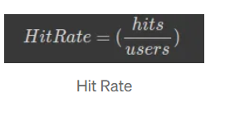
  - Interpretation: Measures success by whether relevant items are present in recommendations.
- Average Reciprocal Hit Rank (ARHR)
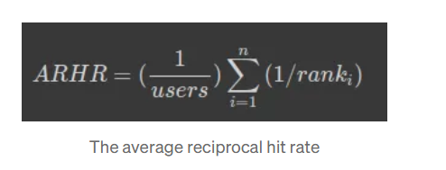
  - A refined version of Hit Rate that also considers the position of the hit in the Top-N list.
  - Hits near the top get higher credit (reciprocal rank), hits near the bottom get lower credit.
  - Encourages placing relevant items higher in the list, improving user experience.

Other Important Metrics
- Coverage
  - Percentage of user-item pairs for which the system can generate predictions or recommendations.
  - Example: If a dataset covers only a subset of movies, coverage would be low if applied to a larger movie database.
  - Trade-off: Higher accuracy may reduce coverage, and vice versa.
- Diversity
  - Measures variety in recommendations across different items or categories.
  - Example: Recommending only James Bond movies is low diversity; recommending a mix of genres is higher diversity.
  - Too low diversity can bore users; too high diversity may reduce relevance. Balance is key.
- Novelty
  - Reflects how "new" or less popular recommended items are to users.
  - High novelty means suggesting items the user is unlikely to know (less popular).
  - Important for user discovery and serendipity, but recommending only obscure items risks losing user trust.
  - Balance needed between familiar/popular items (build trust) and novel items (surprise and delight).

Why Accuracy Alone Is Not Enough
- Accuracy metrics (MAE, RMSE) focus on how close predicted ratings are to true ratings, but recommendation is about ranking and engagement, not just prediction.
- The famous Netflix Prize used RMSE for evaluation, but Netflix did not adopt the winning solution because it did not improve user experience as expected.
- Therefore, modern recommender systems emphasize top-N recommendation metrics and user-centric measures like engagement, diversity, novelty, and coverage.

